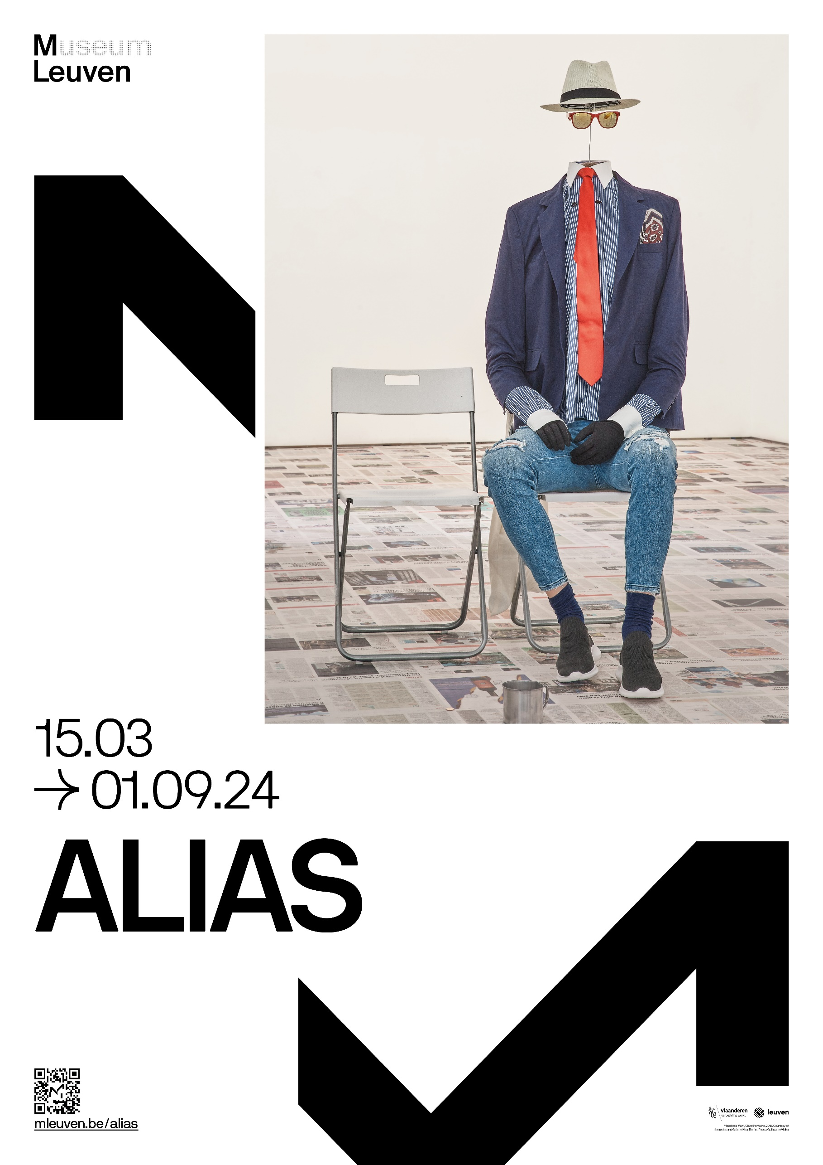

**IN THIS ISSUE**

INTRODUCTION 3

ARTISTS 4

ARTWORKS 5

Lectures 10

MURAL TEXTS 11

ALSO IN M 13

CONTACT 15

# INTRODUCTION

*Alias* is the title of the new group exhibition that opens at M Leuven on 15 March. The subject: fictional artists. In five large galleries, M presents work by artists who have deliberately chosen to obscure their true identities, thereby shaking up our vision of reality.

By adopting a different identity, artists liberate themselves from gender or cultural issues, from art world rules and a capitalist system that turns names into brands. *Alias* brings together some 80 works from public and private collections, both national and international, to highlight this growing phenomenon in recent art history for the first time. Together, they illustrate the strategies that contemporary artists use to merge fiction and reality.

**Strategies in fiction**

The works in *Alias* are displayed across five exhibition spaces. Each of the galleries explores one of the different strategies that contemporary artists use to blur fiction and reality. Behind every fictional artist lies a specific context: it helps us determine how they deploy their fictitious creations and why. Does this new reality primarily relate to the art world or does it emerge in response to wider society?

“In the age of artificial intelligence, fake news and deepfake videos, we are now confronted with an urgent need to make critical distinctions between fact and fiction. But instead of drawing a strict line between illusion and reality, fictional artists allow them to coexist”, says Valerie Verhack, curator of the exhibition. “Fictional artists present their intricately spun fabrications as facts. They don’t leave it up to others to describe and interpret their artistic lives but control their own narrative.”

On the occasion of this exhibition, M is producing a publication in collaboration with Walther König Verlag, with the support of the Fondation Fernand Willame. The book launch takes place on 2 May at M with a ‘lecture performance’ by the British artist Ryan Gander.

**Info**

*Alias* – 15.03 – 01.09.2024

Curated by : Valerie Verhack (M Leuven).

The scenography by : Deborah Bowmann: <https://www.deborahbowmann.com/>

# ARTISTS

The group exhibition *Alias* includes work by the following artists:

Alfred Johansen, Aston Ernest, Bernadette Corporation, Brian O’Doherty, Bruce High Quality Foundation, Charles Rosenthal, Claire Fontaine, Darko Maver, Eleanora Antinova, Emily Feather, Ernest T., Florence Hasard, Hennessy Youngman, Henry Codax, Herman Smit, Hubert Van Es, Jakup Auce, Janez Janša Janez Janša Janez Janša, Jim Jilborn, John Doe co., John Dogg, Justine Frank, Leo Josefstein, Lucie Fontaine, Martin Tupper, NV Panneel, Oksana Pasaiko, Philippe Thomas, Puppies Puppies, Reena Spaulings, Roberta Breitmore, Santo Sterne, Storm van Helsing, Suha Traboulsi, Various Artists, Vern Blosum.

# ARTWORKS

*Alias* brings together some 80 artworks by fictional artists across five exhibition spaces. A selection of the exhibited works are detailed on the following pages. A range of royalty-free images can be downloaded via: <https://mleuven.prezly.com/media>.

**The Bruce High Quality Foundation**

The Bruce High Quality Foundation – a New York-based fictional artistic entity – questioned the notion of individual authorship via the series of sculptures entitled *Mediations*. This is not only a thorny issue within the fictitious The Bruce High Quality Foundation itself, but also within contemporary thinking about Classical Antiquity. *Mediations*, a series of replicas of Greek and Roman artefacts from the collection of the Metropolitan Museum of Art in New York, made in modelling clay, was launched in 2013. The works are a pastiche as much as an homage. The attribution of individual artistry to classical artefacts has been debated ever since the German philologist Friedrich August Wolf questioned Homer’s authorship in his *Prolegomena ad Homerum* (1795): the so-called ‘Homeric Question’. Through *Mediations*, The Bruce High Quality Foundation visually affirms its thesis that individual authorship does not exist. This fictional artistic organisation is the brainchild of some eight artists who met at New York’s Cooper Union art school. They wish to remain anonymous.

**Claire Fontaine**

The fictional artist Claire Fontaine’s sculptures, paintings, videos and texts are critiques on ‘production’ within the capitalist system, which is often dismissed as ‘creation’. She takes her name from Marcel Duchamp’s iconic ready-made – the urinal with the French title *Fontaine* – and the identically named French stationery brand. Claire Fontaine uses the concept of expropriation – ready-mades – to imbue pre-existing objects with an existential value. A common theme in her programmatic oeuvre is political powerlessness. *Headless Man* is a ‘performing object’. Inspired by street performers in tourist hot-spots, the work portrays a creative beggar who objectifies himself to get noticed, thereby erasing his humanity and transforming himself into a headless ‘thing’.

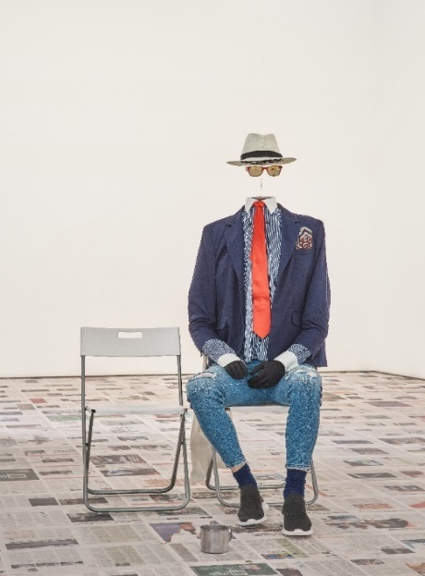

Copyright: Headless Man, Claire Fontaine, 2016. Courtesy of the artist and Galerie Neu, Berlin. Photo credit: Guillaume Vieira

**Ernest T.**

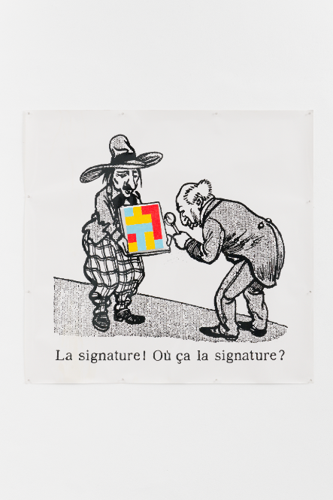

Copyright : La signature! Où ça la signature? Ernest T., 1990

The inspirator behind the fictional artist Ernest T. was born in Belgium. He took his name from an American comic, which allows him to operate in complete anonymity. His oeuvre, in which he questions the value of a signature, among other things, reads like a visual extension of his pseudonym. *La signature! Où ça la signature?* [The signature! Where’s the signature?] belongs to the *Peintures nulles* [Crappy Paintings] series in which his name is omnipresent. The works are composed of several letters T, which are slotted together like a puzzle: his signature and signature painting style in one.

**Henry Codax**

The fictional artist Henry Codax began exhibiting his identically-sized, monochrome paintings in renowned art galleries in New York, Los Angeles and Switzerland in 2011. Codax is everything that the contemporary art world demands of its ‘professional’ artists. Only there is no real Henry Codax. He is a mere caricature of an American monochrome painter – silent, radical, calculating and virile. Codax first appeared in 2004 as a character in Bernadette Corporation’s collectively authored novel, *Reena Spaulings*. The Bernadette Corporation adopted a quasi-corporate identity in protest at globalised culture and the construction of identity via consumption and branding.

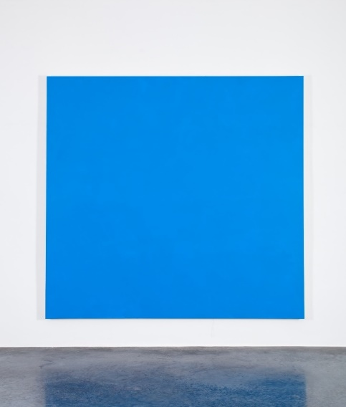

*Copyright: Racer Car, Henry Codax, 2012. Courtesy of Office Baroque. Photo credit: Koen De Wael*

**Paul Devautour & Yoon-Ja Choi**

Art Keller, Richard Allibert and Gladys Clover are just some of the many fictional artists created by French artists Yoon-Ja Choi & Paul Devautour. They practiced under their own names until 1985, at which point they embraced the complexity and layering of various fictional alter egos and different art world roles. They have created a multiplicity of identities that challenge a simplistic and reductive interpretation of the balance of power in the art world. Yoon-Ja Choi & Paul Devautour have not restricted themselves to fictional artists: they have also conjured up an art dealer and event manager, Martin Tupper, not to mention an art critic, Pierre Ménard. Paul Devautour & Yoon-Ja Choi are the ultimate arbiters, therefore, of how their work is understood and received.

**John Dogg**

John Dogg first exhibited his work in Colin de Land’s New York gallery. The accompanying press release stated: his work can only exist if you ignore the artist’s intention and biography. A premise that challenged the hype around certain artists in the 1980s, which was fuelled by the cult of personality. John Dogg’s CV, circulated to collectors and the media, listed his studies in philosophy and linguistics, as well as his involvement in American land art projects during the 1980s. The CV was an amalgam of fact and fiction, based on the experiences and interests of the artists who introduced Dogg as their fictional alter ego.

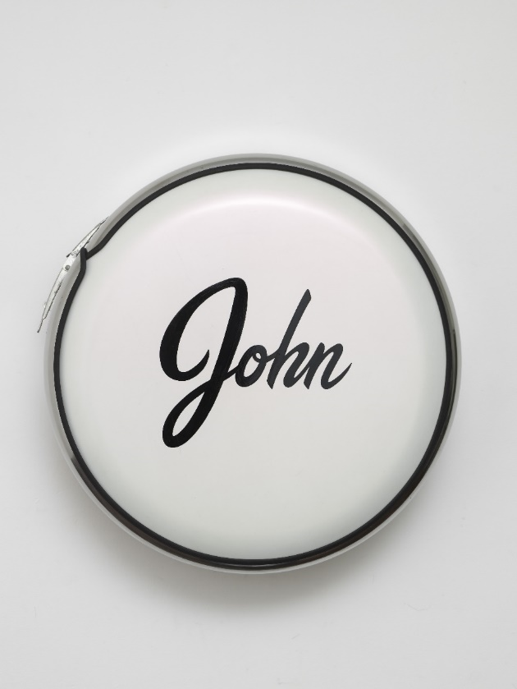

*Copyright: John Not Johnny, John Dogg, 1987. Courtesy of Venus Over Manhattan*

John Dogg’s most recent CV, however, published by the Venus Over Manhattan gallery, lists only one author under the artist’s name: “Pseudonym used by Richard Prince (b. 1947, Panama Canal Zone), active from 1986 to present”. Prince’s then-friend and gallery owner Colin de Land was presumably in collusions with John Dogg. The work *John Not Johnny* takes the form of a white metal tyre casing that alludes to car culture. Mounted on the wall, it resembles an immaculate spare tyre, a ready-made sculpture containing a playful reference to the artist’s name.

**Oksana Pasaiko**

Oksana Pasaiko’s biography in the Manifesta 5 catalogue (San Sebastian, 2004) reads: “In accordance with the artist’s wishes, no details will be published about her life”. Yet it exceptionally mentions that the artist was born in 1982 in ‘Ruthenia’: not an official state but a historical region of Eastern Europe, between Poland, Hungary, Slovakia, Romania and Ukraine. This would suggest that the artist attaches greater importance to her ethnicity than her nationality. The 2005 work *Short Sad Text (Based on the Borders of Two Countries)* comprises seven black human hairs embedded in a bar of soap. They follow the contours of seven contested land borders. Pasaiko has added seven new soap bars to her 2005 work: a necessity due to the troubling political events in the world today.

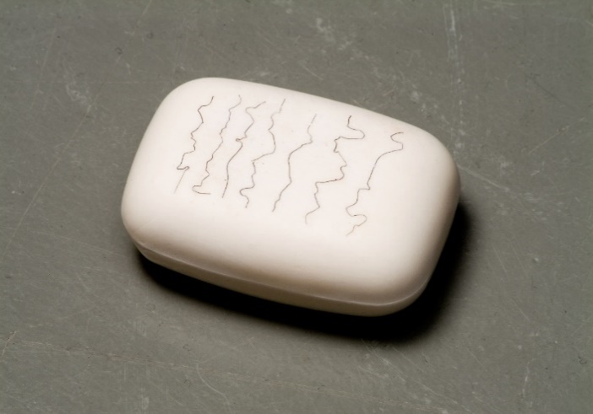

Copyright: Short Sad Text (Based on the Borders of Two Countries), Oksana Pasaiko, Sit. Oct.22, 1949. Collection S.M.A.K., Stedelijk Museum voor Actuele Kunst, Ghent. Photo credits: Dirk Pauwels

**Brian O’Doherty**

Irish-American artist Brian O’Doherty created a five-fold identity in an attempt to liberate himself from art world systems and notions of the ‘self’. He was the first to publish Roland Barthes’ essay *The Death of the Author* while editing an edition of the *Aspen Magazine* in 1967. He has also adopted various authorships in – or as – his work. *Five Identities* is a 2002 group portrait in which O’Doherty poses (far left) on an equal footing with his four alter egos. From left to right: William Maginn, who became a protagonist in one of O’Doherty’s novels; artist Patrick Ireland; art historian Sigmund Bode; and feminist art critic Mary Josephson (seated).

*Copyright: Five Identities, Brian O’Doherty, 2002. Courtesy of Galerie Thomas Fischer. Photo credits: Anthony Hobbs*

**Roberta Breitmore**

Lynn Hershman Leeson started making performance artworks under the alter ego Roberta Breitmore in 1973. Breitmore’s works are landmark feminist critiques of society’s restrictive female stereotypes. Her first performance involved taking the bus to San Francisco and checking into the Dante Hotel. In subsequent years, she opened a bank account and visited a psychologist, for example. Art and life were indivisible: Breitmore does not only appear in images. She had a personality and emotions, and was also someone who consumed, communicated and thus generated paperwork and data. Her activities are documented in drawings and surveillance photos, cheques, credit cards and a driving licence, amongst other things. The Roberta Breitmore project concluded with a symbolic exorcism in 1978.

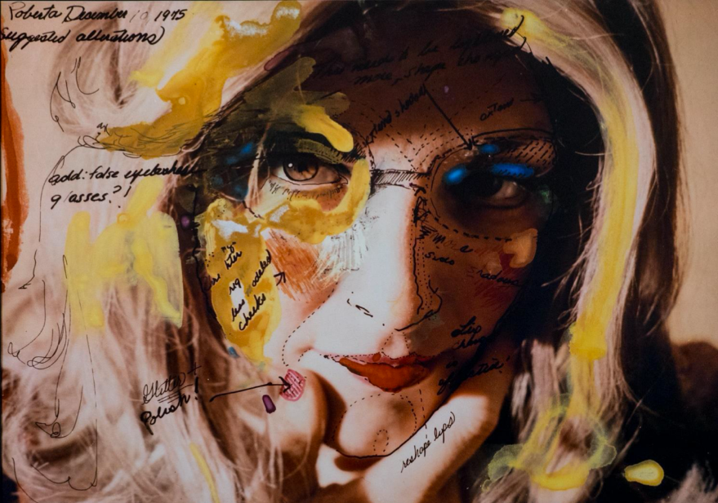

*Copyright: Roberta’s Construction Chart #2, Roberta Breitmore, 1975. Courtesy the artist and Waldburger Wouters.*

**Philippe Thomas**

Philippe Thomas inaugurated the Ready-mades Belong to Everyone® agency in 1987. The dismantling of his authorial status was pivotal to the concept. The project functioned as a supplier of trademarked artworks, which were sold as products. Philippe Thomas thereby signalled the death of copyright. Potential buyers signed a purchase agreement with the agency: a contract outlining the product and author’s details. Ready-mades Belong to Everyone® demolished the distinctions between art and publicity, and between art-theoretical jargon and sales pitches. Posters promoted and sold the dream. *Storia dell’art cerca protagonisti … non aspettate domani per entrare nella storia* [Art history seeks protagonists ... don’t wait until tomorrow to make history] accompanies a half-full bookshelf of art historical monographs. It suggests that your own book might be next in the row.

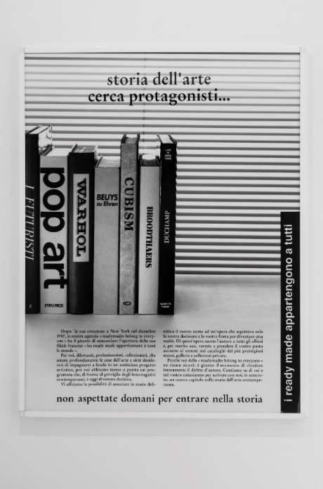

Copyright: Pubblicità, pubblicità, Philippe Thomas, 1988. Courtesy the artist, Jan Mot, Brussels and Claire Burrus, Paris. Photo: Philippe De Gobert, 2017.

**Vern Blosum**

In many ways, Vern Blosum is the ultimate fictional artist. He took his authorial anonymity to radical extremes: only a handful of intimates knew his true identity. Blosum’s artworks started to appear on the commercial art circuit, in a piecemeal fashion, in the early 1960s: invariably Pop Art inspired images of simple objects, with one or more words underneath. His reputation soared thanks to his then gallerist, Leo Castelli, and MoMa in New York acquired his work. A limited biography and lack of further information raised eyebrows, however, and Alfred H. Barr Jr, the director of MoMa at the time, began to suspect that Blosum was an art school prank that had got out of hand. The painting disappeared into storage. Yet Blosum remerged, to great acclaim, in 2013. Exhibitions were staged in several American galleries, followed by a retrospective at the Swiss Kunsthalle Bern. According to an official report, he died in 2017.

Copyright: ‘Forty Minutes’, Vern Blosum 1963. Courtesy of the estate of Vern Blosum and Maxwell Graham Gallery, New York.

# Lectures

**Food for Thought**

Two ‘Food for Thought’ events have been organised to coincide with the exhibition. ‘Food for Thought’ is M Leuven’s exhibition-related programme of lectures, talks and other in-depth activities.

* **Thursday May 2 2024 20:00 - Book launch: *Alias***

The research that preceded the exhibition will be published in the identically titled book, *Alias*. During the launch, British artist Ryan Gander will deliver his ‘performance lecture’ entitled *Loose Association Wretched 20*.

Reservation, no charge: [www.mleuven.be](https://www.mleuven.be/programma/denkvoer-boekvoorstelling-alias)

* **Thursday June 20 2024 20:00 - Film screening: *Orlando, ma biographie politique* [Orlando, My Political Biography]**

Writer, curator and film-maker Paul B. Preciado creates a dialogue with the lives of twenty-six queer, trans and non-binary people to bring the fictional character Orlando to life, who is famous from Virginia Woolf’s eponymous novel.

Reservation and tickets: [www.mleuven.be](https://www.mleuven.be/programma/denkvoer-filmvertoning-orlando)

# 

# MURAL TEXTS

**INTRO**

In today’s world of artificial intelligence, fake news, and deepfake videos, distinguishing between reality and fiction has become more pressing than ever before. But instead of strictly delineating between illusion and facts, some artists allow both to coexist by embodying fictional alter egos. They craft artistic personas complete with their own biographies and present their fiction as if it were fact.

In ‘Alias,’ works of artists who operate under one or more alter egos are brought together. By adopting a different identity, artists can break free from gender or cultural issues, the rules of the art world, and the capitalist system that turns names into brands. Every fictional artist has a unique context that defines their work. This context plays a crucial role in determining the utilisation and rationale behind their fiction. What strategies lie behind fictional artists? Do they develop on the level of the artist themselves? Do they touch upon the art world or emerge as a reaction to society?

Please note: Some works in this exhibition may not be suitable for all ages.

**IMAGINING NAMES**

Artists operating under a fictional alias embrace a blank canvas: a fresh start where everything remains open, including the choice of a name. With fictional artists, this is seldom arbitrary. A new name implies escaping from all forms of predestination, such as a historical identity or psychologically inherited traits. Likewise, choosing a common generic name (John Doe Co., John Dogg) or a political name (Janez Janša Janez Janša Janez Janša) can disrupt the conventional naming system. What is the value of a signature (Ernest T.) or a name stamp (Herman Smit) as a visual sign of authenticity when conceived or placed by fictional artists? In this room, works are shown by fictional artists whose names play an essential role in our experience or interpretation of their work.

It’s worth noting that Western visual art production has traditionally been less inclined to utilise alternate personas, heteronyms, or pseudonyms compared to literature, for instance. From the early Renaissance, Western visual art production shifted from a system rooted in guild cooperatives to individual creativity. The introduction of the artist’s signature coincides with this change, and within this context, few artists deviated from their original names. Since then, artists are expected to create art under their own name and signature precisely because of the significant symbolic value and cultural capital associated with them.

**FACES OF FICTION**

Much like the names of fictional artists, the personas they embrace are typically not arbitrary designations. How do you create (self) portraits of artists who essentially do not exist?

The (self) portrait is synonymous with awareness and is also intrinsically linked to identity: it breathes ‘I exist/they exist’. Artists literally and metaphorically play out the complexity of what that self exactly entails through signifiers linked to gender, origin, or culture. A portrait can be a feminist critique of the restrictive societal image of what it means to be a woman (Roberta Breitmore). Or it can form a critique of ‘production’ within the capitalist system (Claire Fontaine). A group portrait can visualise within which domains of the art world you will profile yourself (Brian O’Doherty). Alternatively, it can serve as a means for the artist to disappear as an author in favour of the network of collectors surrounding them (Philippe Thomas).

Just like in what we consider reality, there is no singular truth. In that sense, fictional artists’ (self) portraits exhibit an affinity with institutional critique: both aim to reveal aspects of reality behind the representations that conceal it.

**THE YOON-JA CHOI & PAUL DEVAUTOUR COLLECTION**

Art Keller, Richard Allibert, and Gladys Clover... They are just a few of the many fictional artists collected by the French artists Yoon-Ja Choi & Paul Devautour. Until 1985, both create art under their own names, only to then embrace the complexity and layered nature of various fictional alter egos and roles within the art world.

A portion of the Yoon-Ja Choi & Paul Devautour collection is exhibited in this room. Martin Tupper, who operates as an artist, critic and at the same time is a fictional alias of Yoon-Ja Choi & Paul Devautour, conceived the arrangement of the collection, which simultaneously evokes a showroom, an art fair booth, or the domestic setting of a private collection. Martin Tupper’s ‘Show Room of the Yoon-Ja Choi & Paul Devautour Collection’ (1992) presents a selection of various artistic movements and tendencies. For example, artist Richard Allibert works exclusively with *readymades*: simple objects or everyday items left unchanged. Buchal & Clavel question the principle of the artist duo together. Artist J. Duplo, on the other hand, exclusively works with Lego bricks.

**REWRITE THE PAST**

Creating a fictional art practice today can also impact the past. By supposedly bringing historically but entirely fictional artists to life with their own context and narrative, a piece of history is corrected. And, although the practices of Justine Frank, Darko Maver or Florence Hasard are figments of imagination, as spectators, we are eager to believe in these stories presented as proven facts.

Their history is brought together by the most diverse pieces of evidence, such as vintage photos and film fragments, press clippings, and documentaries with interviews of those involved, ... Not only the creation of this evidence but also how it is exhibited, and communicated to an audience, reinforces the authenticity of these practices that rewrite the past.

They demonstrate that historiography is not finished but is still in full development. Creating a new version of what the past could have been, often from the perspective of a marginalised social position, undermines the effect of historical distance: as if history is conveniently something from long-gone times that do not concern us.

**DEFYING THE ART WORLD**

Fictional art frequently functions within a framework borrowed from reality; it may encompass historical contexts but just as easily follow the contemporary art world.

Various fictional artists take liberties with the (un)written rules of the so-called art system by portraying themselves as actors from within that art world. Thus, individuals like Leo Josefstein or Hubert Van Es claim to be artists even though they hold very different authoritative roles within the Belgian artistic scene. Alternatively, from a fictional artist like Emily Feather, a desire arises for anonymity and the abandonment of individual authorship.

The anonymous group of artists, Bernadette Corporation, adopts a quasi-corporate identity, to critique a global culture that constructs identity through consumption and branding. In 2005, Bernadette Corporation releases the jointly written novel ‘Reena Spaulings’, which would then serve as the foundation for new artist initiatives such as Henry Codax or the collective project Reena Spaulings, which functions as both an artist persona and an art gallery located in New York.

**THE NECESSITY OF AN ALIAS**

Fictional art can address pressing societal issues such as culture, identity, gender, politics, and censorship. It’s always uncertain whether opting for fictional artistry is driven by the intention to offer a platform for conveying potentially contentious messages.

The works in this room testify to engagement and the relevance of fictional artistry within the societal debate. Does fictional artistry provide a safe position to create politically inspired (Oksana Pasaiko) or explicit work (NV Panneel)? Does fictional artistry imply a means to disappear as an attempt to be free without being judged or discriminated against (Puppies Puppies (Jade Guanaro Kuriki-Olivo))? Are we sufficiently aware that Western art history is often unnecessarily projected as a reference to artworks that don’t even subscribe to that tradition (Suha Traboulsi)? What form takes a fictional art production created within the context of a totalitarian regime (Charles Rosenthal)?

# ALSO IN M

## **Sarah Smolders**

Together with *Alias*, M is also opening a new exhibition by Sarah Smolders entitled *A Space Begins, With Speaking*. The artist (b. 1988, lives and works in Brussels) creates her work in dialogue with a specific space and its architectural features. Smolders observes these characteristics and annotates them through painterly interventions and other elements. Shifts and additions that are barely perceptible at first glance invite the viewer to slow down and to see and experience the space in new and unexpected ways. Smolders uses both the memory of the place and her own oeuvre within this process. After passing through her studio, the ‘residues’ of previous site-specific interventions are incorporated into new exhibitions, as a unique spatial alphabet.

Sarah Smolders brings together different residues in a new spatial intervention for M Leuven.

Smolders will be giving an Artist Talk at M on 16 May as part of ‘Let’s Talk Leuven’. More info on the exhibition here: <https://www.mleuven.be/programma/sarah-smolders>

## **Lola Daels**

M is also launching an exhibition of new work by M-resident Lola Daels on 14 March. Daels spent five months last year as our artist in residence at Cas-co, where she was given the space to delve into her artistic research. Lola Daels creates sculptures and installations in which she questions the notion of authenticity within the current ecological and socio-political context. During her M-residency, she immersed herself in two obsolete Italian techniques: *scagliola* (faux marble) and *pietra dura* (inlaid stone).

Lola Daels’ practice is characterised by extensive material research and labour-intensive experimentation. Central to her oeuvre is the relationship between humans and nature. Her visually seductive works are laced with references to ecological disasters, climate change and the irreversible impact of humans on the planet. M presents the results of her residency from 15 March to 1 September 2024 at the museum.

[www.mleuven.be/programma/toonmoment-m-resident-lola-daels](http://www.mleuven.be/programma/toonmoment-m-resident-lola-daels)

# CONTACT

M LEUVEN  
Vanderkelenstraat 28  
3000 Leuven

www.mleuven.be

Plan your route to the museum

**By bicycle**

Cyclists are welcome! You can easily and safely leave your bike in the cycle park below Rector de Somerplein. From there, it is a two-minute walk to the museum.

**By public transport**

M is a ten-minute walk from Leuven station. The nearest bus stop to the museum is Rector de Somerplein. Use Google Maps to plan your route.

**By car**

The new circulation plan will take you into Leuven and its car parks via several loops. Prefer to avoid city traffic? Park your car in one of the car parks on the outskirts [*randparkings*] and catch a free bus to the city centre. Want to park close to the museum? The closest car park is Ladeuze, which is just a 2-minute walk away. You will also find 18 parking spaces for the disabled (parking height: 1.90m). Click [here](https://www.leuven.be/circulatieplan) for more information on the circulation plan and various parking options.

**Hanne Grégoire**

Head of Communications & Press

hanne.gregoire@mleuven.be

+32 (0)472 95 52 26

**Samantha Fadahunsi**  
Communications & Press Officer

samantha.fadahunsi@mleuven.be  
+32 (0) 491 35 02 95

More information:

**Website link:**

<https://www.mleuven.be/programma/opening-alias-sarah-smolders-en-toonmoment-m-resident-lola-daels>

High-resolution images can be downloaded here on our press page:

**Prezly link:**

<https://mleuven.prezly.com/media>